A picture containing clipart

Description generated with very high confidence

Azure 103 Module 4

Hands On - 10

Azure Certification Training

[**support@intellipaat.com**](mailto:support@intellipaat.com)

**+91-7022374614**

**US: 1-800-216-8930(Toll Free)**

**Azure 103 Module 2, Hands On – 10**

**Using BLOB Storage with Storage Explorer**

**Step 1:** Right click on Blob Container and click on Create Blob Container.

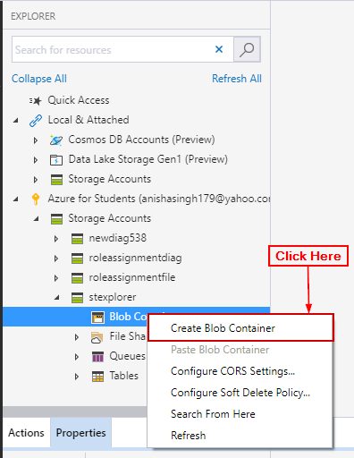

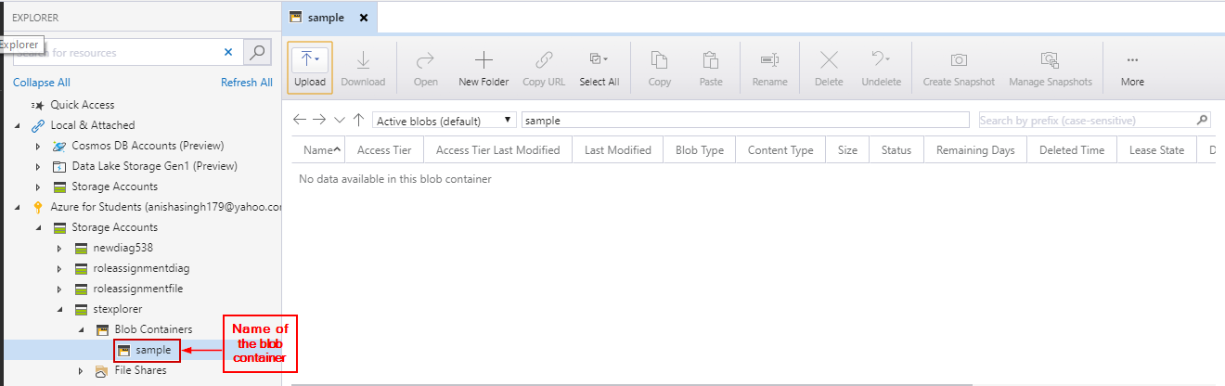

**Step 2:** Click on upload and upload folder.

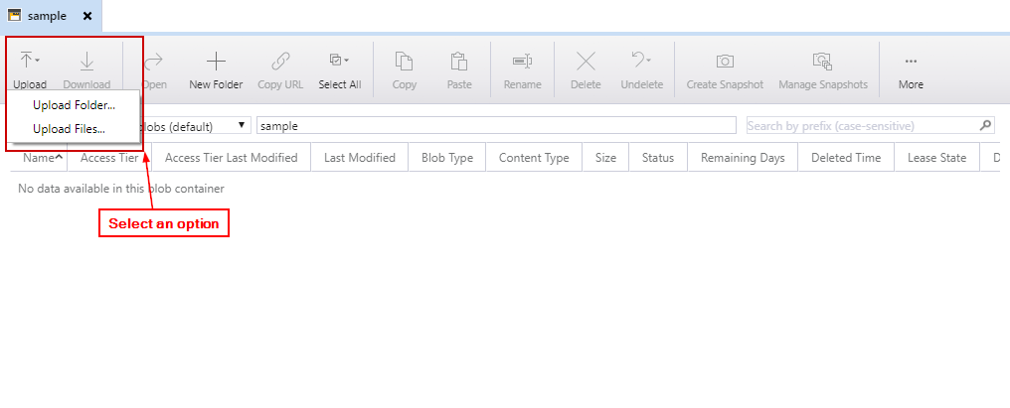

**Step 3:** Select the file and click on Upload.

